July 2023

Article by Dominique LaRoche

The impact of wildfires in the boreal forest
Facts
Canada’s wildfire season is the worst in recorded history.
As of June 28, 3,003 fires had burned 7,974,000 hectares (19,704,183 acres).
Smoke emitted from the wildfires has caused air quality alerts and evacuations in Canada and the United States. More than 75 million people were under air quality alerts. By late June it had crossed the Atlantic to reach Europe.
In Canada, roughly half of all fires are now caused by lightning. Lightning strikes are on the rise and expected to increase with climate change.
Because of climate change, the vegetation is more likely to be dry and more flammable. Canada's fire season has been starting approximately one week earlier and ending one week later.
Between twenty and thirty percent of the carbon held in forests in the world is in the boreal forest. But most of the carbon is found in the permafrost. https://daily.jstor.org/climate-changes-dangerous-effects-on-the-boreal-forest/ and https://news.mongabay.com/2009/11/new-report-boreal-forests-contain-more-carbon-than-tropical-forest-per-hectare/
In fact, boreal forests store nearly twice as much carbon as tropical forests per hectare: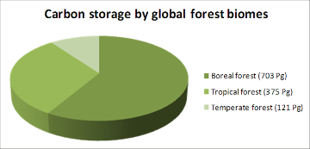
Source: https://news.mongabay.com/2009/11/new-report-boreal-forests-contain-more-carbon-than-tropical-forest-per-hectare/
Boreal forest fires usually make up 10% of global wildfire-related carbon emission. But in 2021, their contribution soared to 23%.

Clean air Canada?
Waking up in Montreal on an easy Sunday morning, I went outside to drink my coffee and read the news. I was immediately choked by a heavy smog covering the skyscrapers for as far as I could see, like a deadly blanket. The smog was caused by the burning forests North of Quebec. Since early spring, a record number of fires has raged in areas so far away that we typically barely acknowledge what is at stake with its devastation. In Northern Quebec alone, 1,729 740 acres of forests are burning uncontrollably (which is 40 times the average rate of the last 10 years). But this year, the wakeup call is loud and clear, as a toxic smog travels all over the province, towards Ontario and the Northern United States, clouding cities like New York, Chicago and Minnesota, Illinois, Kentucky and Indiana. The air quality reaches hazardous levels for the public health, as many outdoor activities are cancelled, and the population is asked to stay inside.

« According to IQair, a Website that rates air quality in all the major cities in the world, Montreal sadly ranked first as the most polluted.» Journal Lapresse, mardi le 27 juin 2023

Montreal! …a Canadian city that is usually ranked with good air quality; that aggressively promotes collective transportation and bicycle paths, green urban planning and composting, cannot even supply its citizen with a better air quality than overpopulated cities like Delhi, Jakarta and Kuwait. What is going on?
My friend works in James Bay, up North, where the summer temperature is 17 Celcius on average. He just called me to announce with fear that the thermostat had reached 30 Celcius today, and summer is barely starting there. The raging forest fires and climate change put more and more pressure on the temperature up North.

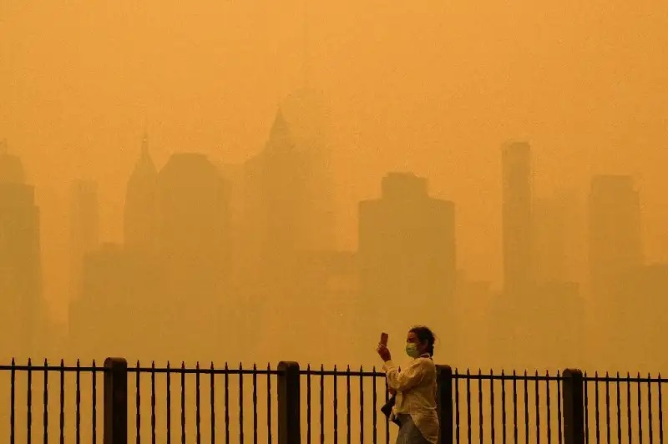

New York City, covered in the smog from canadians fires, June 7th, 2023. Phys Org.

Aside from causing eye irritation, smoke from fires can also carry harmful particulate matter far and wide.
Particles with a diameter of less than 10 microns are dangerous — they can be inhaled deep into the lungs or even get into the bloodstream due to their small size. From there, they trigger inflammation of the airways and other organs, including the heart, kidney and liver. Inflammation sets off the body’s defense system, which can injure cells, alter gene expression, and lead to scarring and disease. https://www.statnews.com/2023/06/07/the-canada-wildfires-are-exposing-the-harmful-effects-and-health-inequities-of-air-pollution/

Not in my backyard!
I used to think that the impact of Climate Change would not affect us, up North, before a long, long time; that we were protected by our colder weather, abundant rain, rivers and lakes, and vast, unpopulated territories. The fires are a brutal wake up call. There is no boundary protecting us from Climate Change. No walls. No armed customs keeping the bad stuff away. Climate Change is a great unifier: it will hit everyone in the face. Everyone.

The burning of the boreal forest a potential catastrophe for Climate Change?
Hundreds of forest fires since early May (2023) have generated nearly 600 million metric tons of CO₂, equivalent to 88 percent of the country's total greenhouse gas emissions from all sources in 2021, the Copernicus Atmosphere Monitoring Service (CAMS) reported.
More than half of that carbon pollution went up in smoke in June alone.
The emissions from these wildfires are now the largest annual emissions for Canada in the 21 years of our dataset," CAMS said in a statement. https://phys.org/news/2023-06-canada-co2-emissions-year.html

« The boreal forests, which cover huge swaths of Canada, Russia and Alaska, are the world’s largest land biome. They are also carbon dense, releasing 10 to 20 times more planet-heating carbon pollution for each unit of area burned by wildfires than other ecosystems », says Steven Davis, professor of earth system science at the University of California. Due to a phenomenon called polar amplification, the ring of forest around the Arctic represents the fastest warming biome on the planet.

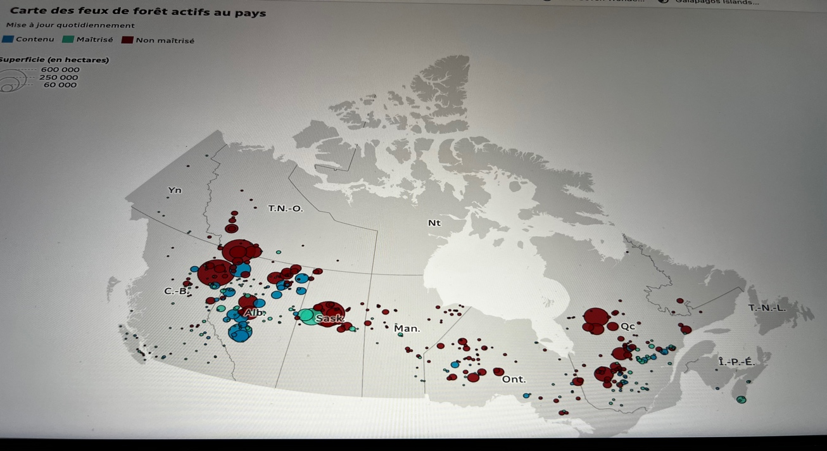

Across Canada, the precious boreal forest is burning: The big round dots represent, on the picture below, the fires still burning out of control.(source: https://ici.radio-canada.ca/info/2023/evolution-carte-incendies-feux-de-foret-canada-quebec/)

I was extremely surprised to learn that in Canada, our managed forest (65% of all forests) is actually more of a carbon source than a carbon sink! « That's because trees don't just absorb carbon when they grow, they emit it when they die and decompose, or burn. When you add up both the absorption and emission, Canada's forests haven't been a net carbon sink since 2001. Due largely to forest fires and insect infestations, the trees have actually added to our country's greenhouse gas emissions for each of the past 15 years on record». https://www.cbc.ca/news/canada/calgary/canada-forests-carbon-sink-or-source-1.5011490
In the same article, the journalist mentions that Canada excludes the emissions from its forest when setting GHG emission target. And those numbers mentioned above don’t include our wild boreal forest…
Globally, around 80% of the carbon released by forest fires is later reabsorbed by the vegetation regrowth on the next season. The leftover, around 20%, stays in the atmosphere and contributes to CO2 accumulation. La forêt boréale brûle de plus en plus, et c’est un problème pour le climat. Radio-Canada. Published March 3rd, 2023

Specificities of the boreal wildfires
The boreal forest’s trees burn faster; take more time to regenerate, and creates more greenhouse gas compared to tropical forests, due to a lower degradation of the organic matter. As reported by the Washington Post, « The smoke produced by the boreal forest fires is incredibly dense and foreboding. Unlike many forest fires where flames tear through the tree crowns and move on, boreal forests burn as much at the ground level because of extensive flora as well as other biomasses like peat». As the fires intensify, the carbon stored in lower layers of the soil could burn and be released in the air, as explained in Nature magazine:

«Climate warming and drying has led to more severe and frequent forest fires which threaten to shift the carbon balance of the boreal ecosystem from net accumulation to net loss, resulting in a positive climate feedback. This feedback will occur if organic-soil carbon that escaped burning in previous fires, termed legacy carbon, combusts. (…) In forests that were in dry landscapes and less than 60 years old at the time of the fire, legacy carbon that had escaped burning in the previous fire cycle was combusted. As boreal wildfires continue to increase in size, frequency and intensity, the area of young forests that experience legacy carbon combustion will probably increase and have a key role in shifting the boreal carbon balance». https://www.nature.com/articles/s41586-019-1474-y

Added to this vicious cycle where frequent and intense wildfires modify the ecosystem of the boreal forest is the thawing of the permafrost.
The boreal forest stores roughly a third of all land-based carbon in the world, mostly in the soil. The northern hemisphere’s cold temperatures prevent dead biomass from breaking down, storing carbon for thousands of years deep in the permafrost. https://www.cnn.com/2022/04/27/world/boreal-forest-wildfires-carbon-climate/index.html

As shade-providing trees are burnt away, the carbon-rich permafrosted lands are exposed. https://earth.org/data_visualization/permafrost-thaw-and-methane-emissions/ Its thawing will cause enormous amount of carbon and methane to be released in the atmosphere.

Boreal forest resilience
« Boreal forest recovery may be severely limited by the lack of seed sources or bud banks and state-changes may occur, subverting stand self-replacement expectations and shifting the balance of vegetation types on the landscape» . Nature. Short-interval wildfire and drought overwhelm boreal forest resilience.

Intensifying wildfire activity and climate change can drive rapid forest compositional shifts: «In boreal North America, black spruce shapes forest
flammability and depends on fire for regeneration. This relationship has helped black spruce maintain its dominance through much of the Holocene. However, with climate change and more frequent and severe fires, shifts away from black spruce dominance to broadleaf or pine species are emerging, with implications for ecosystem functions including carbon sequestration, water and energy fluxes, and wildlife habitat». https://www.pnas.org/doi/10.1073/pnas.2024872118

SOLUTIONS:

Reducing CO2 emissions that creates the problem in the first place is the obvious long-term solution. In the near term, however, some mitigation would be critical to avoid large scale forest fires and grow back the forest as quickly as possible.

Regenerate, Manage
Although wildfires are naturally occurring and promote the ecosystem’s regeneration, the climate crisis brings the intensity and number of wildfires to a level never seen before. Targeted reforestation after wildfires as well as forest management start to stand out in the array of options to preserve and protect our boreal forest: «To add more hardwoods to the boreal forests when replanting can decelerate the progression of the next fires. Handling the organic matter on the ground, acting as fuel, is also important to manage fire prevention », according Jean-François Boucher, Professor at UQ of Chicoutimi and environment specialist. The community level action refers mainly to the Natives’ preventive burn and ancestral land management technics. More and more, experts realize what a precious resource the Native’s knowledge and practices can be to manage the boreal forests. Not only has it been their natural habitat for time immemorial, but they also suffer directly from its destruction: the Natives constitute 50% of the evacuated population from wildfires, although they represent 5% of the population. They depend directly on the resources of the forest to survive.
Hugo Asselin, himself a Native American, and a university professor at Abitibi-Temiscamingue UQ, explains that «The First Nations communities delt with boreal forest fires as part of nature and knew how to use controlled fires preventively. They protected the territories from wildfires and promoted the growth of certain foods, such as berries. As semi-nomads, they had a deep knowledge of the land and its specificity. Keeping its balance, assessing the dangerous zones, and managing the forest is an integral part of their culture. A long time ago, the nomads would protect their community from out-of-control fires by moving around the lands to escape the danger. Now, this mobility is restricted, as well as their ability to use preventive burns to manage wildfires (due to government legislations) ». https://ici.radio-canada.ca/ohdio/premiere/emissions/moteur-de-recherche/segments/entrevue/446700/feux-foret-methodes-traditionnelles-autochtones

« The right to burn, to steward the land, to maintain safety around communities – it has to come back (…). We call it cultural burning, it’s used to maintain the land in a good way, (for) medicines and our forage needs » stated Fire Keeper Joe Gilchrist (Skeetchestn Indian Band).
Interview with Guillaume Proulx
Looking for a closer look at the boreal forest wildfires and possible solutions, I interviewed Guillaume Proulx, a doctorate student specializing in the boreal forest, under the supervision of Prof. Asselin: « The boreal forest is one of the largest biome on the planet; representing roughly 10% of the global carbon well, with its rich wet lands, peat and swamps. Although there are a few species of trees dominating the boreal forest, it is a very diversified ecosystem, rich in resources and crucial for the carbon, nitrogen and water cycle. »
When I asked the present state of the boreal forest, he immediately mentioned the 3 main perturbators: the forestry, mining and power industries. He deplored the clearcuts still practiced by the forest industry despite the current regulations and the reforestation of ancient forests with a single specie aiming at short term profits instead of the balance of the ecosystem; the large areas flooded for hydro-electric dams; and the soil contamination and intense machinery activities by the mining activities. All this leaves our forests unbalanced and vulnerable to external stress.
«This year, in the Quebec boreal forest, we have the perfect storm: on top of industrial activities making forests more vulnerable, we have exceptional drought and heat, hence the record number of wildfires and an epidemic of predatory spruce budworm», explains Proulx.
« Before the arrival of Christophe Colombus in America, preventive fires were a common practice to manage the forest. Settlers reported using existing roads going inland; Natives were creating opened corridors for migrating birds and animals; forests were kept from invading plains and wetlands. They would practice selective culture of hardwood, less flammable essences of trees, around their community. They would use preventive tree cutting or spring and fall fires to control and protect the surroundings of populated zones or exceptionally rich medicinal plant and food area. They would manage the organic matter covering the soil, potentially acting as fuel during a wildfire, as well as cutting the lower layer of branches along the trails to slow down fire propagation and ease access. They installed their gathering sites according to dominant winds; preferring high altitude, sandy areas less prone to wildfires. » says Dr Proulx.
Gradually, these practices were lost as the Native’s got pushed to reserved areas; forbidden to walk and manage the vast territory or to apply fire prevention measures. Let’s also keep in mind that, since the colonization of America in 1492, 90% of the estimated 60 to 80 million Native Americans (both North and South America) disappeared. The Pristine myth. The landscape of the Americas. Denevan. 1992.
«Forest fires are part of the restorative process of the ecosystem. Natives lived in harmony with nature and integrated fires as a tool instead of seeing it just like a threat to be avoided, as we do now », continues Guillaume Proulx.
The Natives were acting as the Gate watchers of the forest as an ecosystem. It is now left in the hands of whoever use it as an economic resource. With the climate changes, it is not surprising we witness the rapid destruction of an ecosystem that was left unattended and vulnerable.

The good news is that the Canadian government is including more and more Native Americans on environment protection panels and discussions. Smart Fires, a guide for wildfire prevention, was created in collaborations with the First Nations. Although many Natives I talked to on a Reserve West of Montreal sadly reported having lost the traditional knowledge their ancestors used for fire prevention, integrating Native’s practices is certainly a step in the right direction.

Call to action:
As active, voting and breathing citizens, we have a role to play: we should keep a close watch on how the governments manage forest and its resources; push for investing more money and resources to achieve faster and more aggressive firefighting interventions; and make sure that environmental questions are always considered in all decision making. As Guillaume Proulx, my interviewee for this article, said when asked what should be done at the government level to make a real difference: « There should be an environment minister in each ministry! Each decision should consider the environmental impact. The segmentation of ministries creates a tunnel vision in decision making. Maintaining a sustainable future should be, now more than ever, our top priority».

References:
Journal La Presse, mardi le 27 juin 2023

The Washington Post, By Ian Livingston
June 26, 2023 at 7:00 a.m. EDT
https://www.nature.com/articles/s41586-019-1474-y

https://lactualite.com/environnement/incendies-de-foret-le-quebec-joue-t-il-avec-le-feu/
https://www.pnas.org/doi/10.1073/pnas.2024872118
Vox By Li Zhouli@vox.com Updated Jun 29, 2023
The Pristine myth. The landscape of the Americas. Denevan. 1992.
Hugo Asselin: Interview at Radio-Canada. https://ici.radio-canada.ca/ohdio/premiere/emissions/moteur-de-recherche/segments/entrevue/446700/feux-foret-methodes-traditionnelles-autochtones

Ref supplied by Andre-Yanne Parent, Climate Reality:
Sur les impacts des feux sur la résilience de la forêt boréale, menée par Ellen Whitman : https://link.springer.com/content/pdf/10.1038/s41598-019-55036-7.pdf
- Le déclin de l’épinette noire dans la forêt boréale et les impacts pour la lutte aux changements climatique, menée par Jennifer L. Baltzer : https://www.pnas.org/doi/10.1073/pnas.2024872118
- Des données graphiques (assez terrifiantes) du Centre canadien des feux de forêt : https://ciffc.net/statistics
- Ces analyses de CBC explain sont également très bien faites : https://www.cbc.ca/news/climate/canada-wildfire-data-change-1.6854186
- Le profil national des risques en matière de feux de forêt du Gouvernement du Canada ( sélectionné la section sur les feux de forêt) :https://www.securitepublique.gc.ca/cnt/mrgnc-mngmnt/ntnl-rsk-prfl/index-fr.aspx

Ref by Guillaume Prouxl :
- Sur des communautés qui pratiquent le brûlage préventif : http://nationnews.ca/community/fire-keepers-bring-back-cultural-burning-traditions/
- Une revue de littérature à ce sujet : https://link.springer.com/article/10.1007/s40725-022-00168-9
- Le guide de brûlage culturel de FireSmart : https://firesmartcanada.ca/product/blazing-the-trail-celebrating-indigenous-fire-stewardship/

http://nationnews.ca/community/fire-keepers-bring-back-cultural-burning-traditions/

